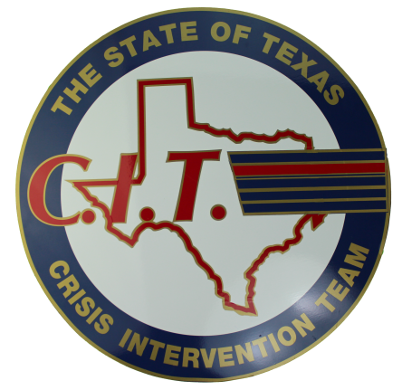
The 5th Annual Texas CIT Association Conference
Fort Worth, TX
May 3rd-5th, 2018

Call for Award Nominations
Deadline for Nomination: March 30, 2018

Submit all nominations in a one document attachment to jon.sabo@sanantonio.gov , gussie.fuller@houstonbehavioralhealth.com, jjones@rowlett.com. All nominees must be members of TCIT.

- Name of Nominee
- Organization
- Contact information
  - Address
  - Phone Number
  - Email
- 150 word abstract- Describing the person and their accomplishments toward Mental Health Awareness, Advocacy, TCIT, and/or Mental Health Education
- Category for which Nominee is submitted.
  - Award of Excellence
  - Organization of the Year
  - Mental Health Professional of the Year
  - Mental Health Peace Officer of the Year
  - Texas CIT Award

If you have any questions, please contact jon.sabo@sanantonio.gov. Awards will be presented at the 2018 TCIT Fort Worth Conference

Award Descriptions:

Award of Excellence:
Awarded to the individual whose support, dedication, work, ideas, and/or strides toward improving community knowledge and education has significantly impacted the field of Crisis Intervention.

Organization of the Year:
Awarded to the Organization lending the most outstanding collaborative mental health support to law enforcement within the community.

Mental Health Professional of the Year:
Awarded to the mental health professional who is working with law enforcement to make the most significant improvement to mental health responses within the community.

Mental Health Peace Officer of the Year:
Awarded to the law enforcement officer making the most effort to improve mental health response in his or her profession and/or community.

Texas CIT Award:
Awarded to the Association member who has exhibited the most effort to make a positive impact on community mental health across the State of Texas and whose dedication to the Association is exemplified in these efforts.

